Wisdom Circle – Brave, Honest Community
September 2019

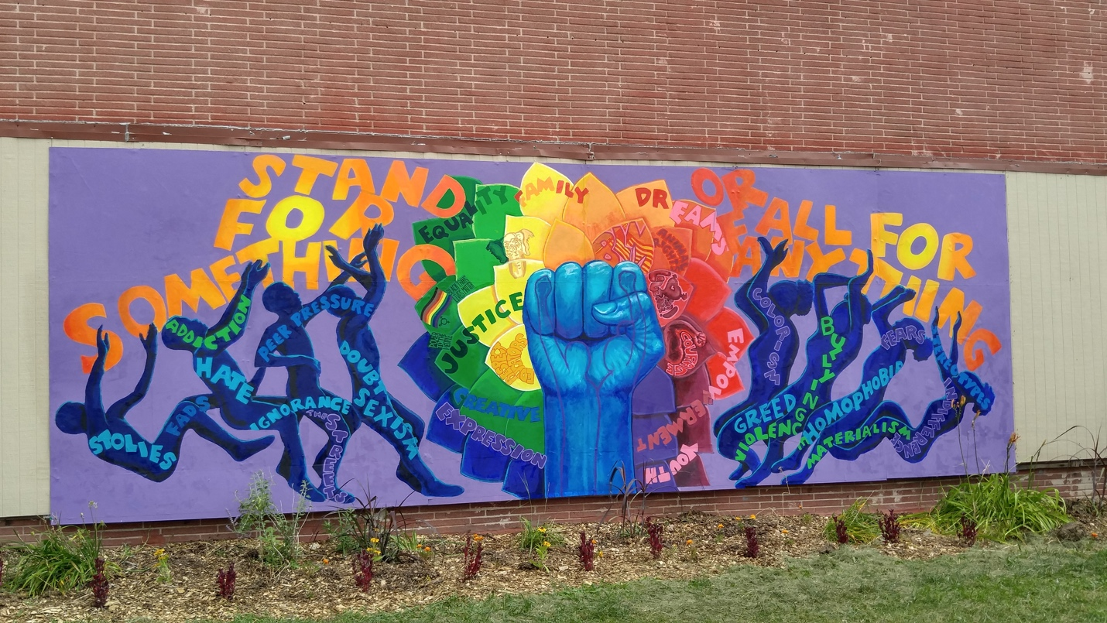
Mural at Running Rebels Community Organization. Photo by Zach Komassa. Source: https://urbanmilwaukee.com/2018/08/07/safe-sound-unveils-another-youth-mural/

Chalice Lighting , by Bruce Southworth
For the gift of this day and for our community of spiritual nurture and compassion, we give thanks.
We light this chalice as a symbol of our faith.
May our many sparks meet and merge in communion of heart and soul

Silence- Take three minutes to settle into this space, to fully arrive. You may also use this
time to reflect about the chalice lighting words above.

Check-In
As you feel comfortable, take 2-3 minutes to share whatever you need to share with this group in order to be fully present. This is a time for sharing, but not for discussion.

Business
Use this time for any new business: welcoming new members, scheduling future meetings, revisiting/reciting the covenant, answering questions about wisdom circle processes, etc.

Since this is the first meeting of this new cycle of Wisdom Circles, I encourage you to take a significant amount of time to review, edit, and co-create your group’s covenant. As you prepare to engage in this discussion, I invite you to think about:
- What do you need from this group to feel comfortable sharing during meetings?
- What are you willing to offer this group?
- How can you create a covenant that is inclusive of all who are present as well as those who may join you in the future?

Make sure someone takes notes and shares the new covenant with all members. Below you’ll find the current Wisdom Circles Covenant.

Wisdom Circles Covenant

As group members,...

Before our meetings, we agree to:
• make meetings a priority, including being on time.
• contact the facilitator (or one of the co-facilitators) ahead of time if we are unable to attend.
• read the material and attempt the assigned spiritual exercise.

During our meetings, we agree to:
• participate in discussion of the reading material and exercise by engaging each other’s ideas with inquisitiveness and support rather than debate, dismissal or argument.
• monitor our own participation so all members have opportunities to speak.
• refrain from interruption during times of personal sharing
• speak for ourselves and try to speak from both the heart and the intellect.
• make time to say good bye when a member decides to leave the group.
• periodically revisit, edit and re-affirm this covenant as a group.

After our meetings, we agree to:
• be willing to follow up with other members as needed, especially any who miss a meeting without notice to make sure they are okay.
• respect the privacy of group members by keeping personal information confidential.
• keep each other in our prayers and hearts, reaching out to each other in tangible ways as we feel comfortable.

Spiritual Exercise
Share any insight, learning, lesson gained from doing or resisting this month’s spiritual exercise. (Focus on your heart/emotions/spirit/personal experience). Because this is a section for personal sharing, attentive listening and no-crosstalk is recommended.
Choose one of the following spiritual exercises:

- How do we build community? – your task this month is to reflect on the questions I posed before about covenants. What changes would you make to the current covenant to foster a brave and honest group? What are you willing to offer and what are you hoping others can offer as well? Take some time this month, before your group’s meeting, to ponder these questions.

How was this experience for you? What insight did you gain?

Discussion of Reading and Words of Wisdom
Take turns reading the words of wisdom. Share about the one(s) that caught your attention. Discuss the reading and the questions below. Crosstalk can enrich your conversation here (avoid judging or wanting to “fix” things, and speak from your own experience, avoiding generalizations, and identifying who you mean when/if you use the word “we”).

Words of Wisdom

“It takes a great deal of bravery to stand up to our enemies, but just as much to stand up to our friends.” ― J.K. Rowling

“Courage is grace under pressure.” ― Ernest hemingway

"There is no power for change greater than a community discovering what it cares about." – Margaret J. Wheatley
"In every community, there is work to be done. In every nation, there are wounds to heal. In every heart, there is the power to do it. – Marianne Williamson

Brave, Honest Community by Rev. Tania Márquez

The monthly themes this year were selected with help from members of the Journey Toward Wholeness team as well as from other worship associates and those involved in worship planning. This isn’t the first time we’ve talked about community, but I’ve been thinking about the adjectives added to this month’s theme “brave, honest”.
In this community we often emphasize the need to be a welcoming community or to be a compassionate and caring community. It makes sense, I would say, because it seems like to create community you need caring individuals who look after each other.
This month’s theme, though, adds a couple of more ingredients to a collective ideal of community. Who can argue against courage and honesty? Would anyone choose, knowingly, a community that chooses not to take risks or that becomes stagnant because fear won’t let it move forward? How about a community that avoids truth-telling or that avoids seeing itself as is, in all honesty, with its growing edges and shadow sides?
At first, I thought that brave and honesty were two separate qualities, but they are connected. Courage, or bravery, is required to choose to peek into the areas that aren’t as pretty. But those are the areas that are often in most need, the areas that need more attention, that have been neglected for way too long. Perhaps, this brave honesty can also be a form of self-love.
Perhaps, we cannot separate a brave and honest community from a compassionate and caring one. Each element is necessary to create balance, to create spaces where when the truth is spoken boldly, when shadow sides are revealed or when disagreements arise, no one is left behind or outside of it.

Gratitude: Share 1-2 things that have been meaningful to you from this session.

Extinguishing of the Chalice:

Words by Samuel A Trumbore
Go forth in simplicity.
Find and walk the path
that leads to compassion and wisdom,
that leads to happiness, peace and ease.
Welcome the stranger and
open your heart to a world in need of healing.
Be courageous before the forces of hate.
Hold and embody a vision of the common good that
serves the needs of all people.

