Wisdom Circle – Generous Spirit
May 2019

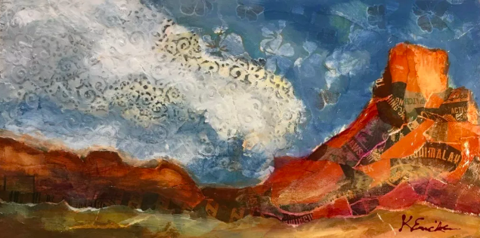 Artist Credit: “Light Radiant Cloud” by Kathy Ericksen

Chalice Lighting – song by Rabbis Joseph and Nathan Segal
Our chalice lighting this month is a singing chalice lighting! Take the time to sing this 3–4 times in unison.

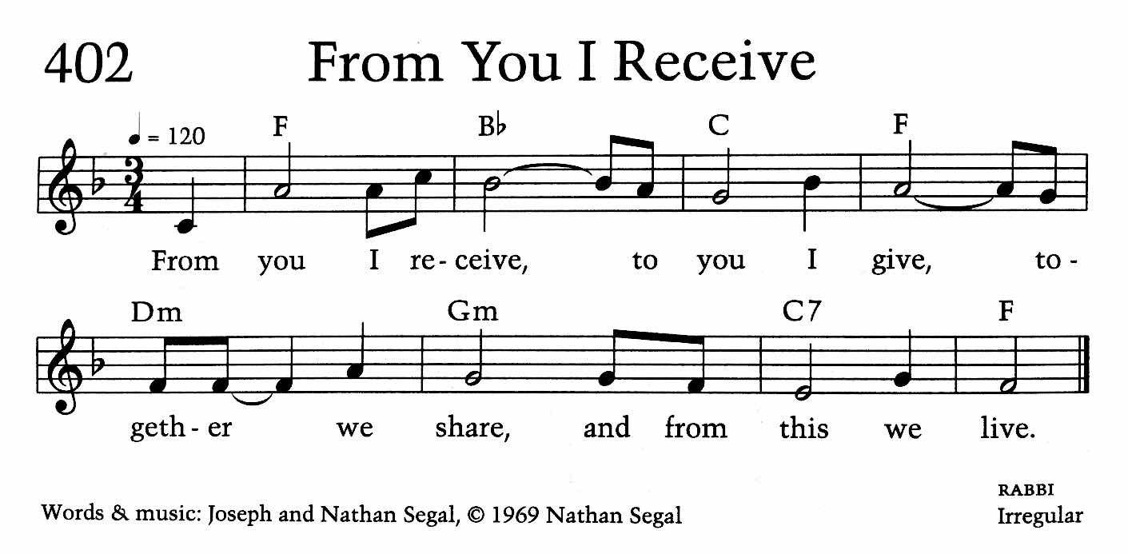

Meditation- Take three minutes to settle into this space, to fully arrive.
Your facilitator can keep track of time.

Check-In
As you feel comfortable, take 2–3 minutes to share whatever you need to share with this group in order to be fully present. This is a time for sharing, but not for discussion.

Business (approx. 10 min)
Use this time for any new business: welcoming new members, scheduling future meetings, revisiting/reciting the covenant, answering questions about wisdom circle processes, etc…

Spiritual Exercise
Share any insight, learning, lesson gained from doing or resisting this month’s spiritual exercise. (Focus on your heart/emotions/spirit/personal experience). Because this is a section for personal sharing, attentive listening and no-crosstalk is recommended.
Choose one of the following spiritual exercises:

- Time – Find a new way to volunteer your time this month. Perhaps it’s with the migrant family shelter, or at a local community center. Or check First Church’s weekly The Window publications for opportunities! When you’re engaged in volunteering your time, remember to pay attention to the experience. Even amidst the busyness of our lives, notice how the experience of being generous with your time impacts you and those you’re helping.

- Talent – Our gifts are numerous, and in community, they are diverse! Find a way this month to offer your skills and abilities to a person or community in need. If you’re a great cook, consider cooking for someone else. If you’re an organized person, consider helping a group get organized. How does this experience help you appreciate your gifts, and the gifts of others?

- Treasure – Consider donating your money to an organization or group whose work reflects your values. If you already regularly do so, perhaps seek out a new one. Take some time to learn about the organization, trying to understand what impact sharing your treasure will have. How does supporting this group monetarily connect you more deeply to their work?

How was this experience for you? What insight did you gain?

Discussion of Reading and Words of Wisdom
Take turns reading the words of wisdom. Share about the one(s) that caught your attention. Discuss the reading and the questions below. Crosstalk can enrich your conversation here (avoid judging or wanting to “fix” things, and speak from your own experience, avoiding generalizations, and identifying who you mean when/if you use the word “we”).

Words of Wisdom

“All we have is just on loan. Whether it be our next breath, the food we eat, what is in our pocketbooks; it is on loan and we cannot take it with us when we go.”
—Rev. Stephen Gray (contemporary UCC Minister)

“Each smallest act of kindness, reverberates across great distances and spans of time—affecting lives unknown to the one who’s generous spirit was the source of this echo. Because kindness is passed on and grows each time it’s passed until a simple courtesy becomes an act of selfless courage, years later, and far away.”
—Dean Koontz (contemporary American novelist)

“Attention is the rarest and purest form of generosity.”
—Simone Weil (20th cent. French Christian mystic)

“Generosity is more than just ‘giving up.’ Generosity generates its power from the gesture of letting go. Being able to give to others shows us our ability to let go of attachments that otherwise can limit our beliefs and our experiences.”
–Sharon Salzberg (contemporary mindfulness teacher)

“Water the fruit trees, and don’t water the thorns. Be generous to what nurtures the spirit and God’s luminous reason-light. Don’t honor what causes dysentery and knotted up tumors.”
—Jalaluddin Rumi (13th cent. Sufi Muslim poet), trans. by Coleman Banks

“That’s what I consider true generosity: You give your all, and yet you always feel as if it costs you nothing.”
—Simone de Beauvoir (20th cent. French philosopher)

Reflection: Generous Spirit – Stevie K Carmody, intern minister

“Generous Spirit,” this month’s theme, reminds me of something my English teacher in high school taught us: we have a choice to read things compassionately and generously, or to read things cynically and skeptically. So, for example, when presented with a character’s questionable action, do we try to understand them in their context and history, or do we try to ascribe to them selfish motives?

Well, I’ve learned that both interpretations—the cynical and the generous—provide us with important information about people and the world, not just literature. Neither can be discarded. But growing my generous and compassionate spirit—through practice and reflection—has been important spiritual development for me. Some of it means bringing the wisdom of my past experiences to bear on my encounters with the world. Some of it means bringing a curiosity: “Hmm, I wonder what’s going on for them?” But it’s not always easy work!

What does a generous spirit mean to you? How can you bring it to the world? How have other people shown it to you?

Part of that generous spirit, I think, needs to be acted out in the world: through generosity. At First Church, we talk about offering your “Time, Talent, and Treasure” to the congregation. I like this framing because it names money as a way to give, but recognizes and values other ways too. May we resist the notion that someone’s value to our community is based solely on their pledge amount.

Generosity, it seems to me, is not a transactional business. But it’s an act in the world that cultivates more generosity. In this way, I see generosity tied to gratitude and grace. To receive a gift inspires giving a gift. As our chalice lighting song remind us: in our sharing, so is our living.

How have you acted on generosity in your life? Who taught you about acts of generosity?

Gratitude: Share 1-2 things that have been meaningful to you from this session.

Extinguishing of the Chalice: by John Daniel

Among other wonders of our lives, we are alive with one another, we live here
in the light of this unlikely world that isn’t ours for long.
May we spend generously the time we are given.
May we enact our responsibilities as thoroughly as we enjoy
our pleasures. May we see with clarity, may we seek a vision
that serves all beings, may we honor the mystery surpassing our sign,
and may we hold in our hands the gift of good work
and bear it forth whole, as we were borne forth by a power we praise
to this one Earth, this homeland of all we love.

