Wisdom Circle – Balance
March 2019

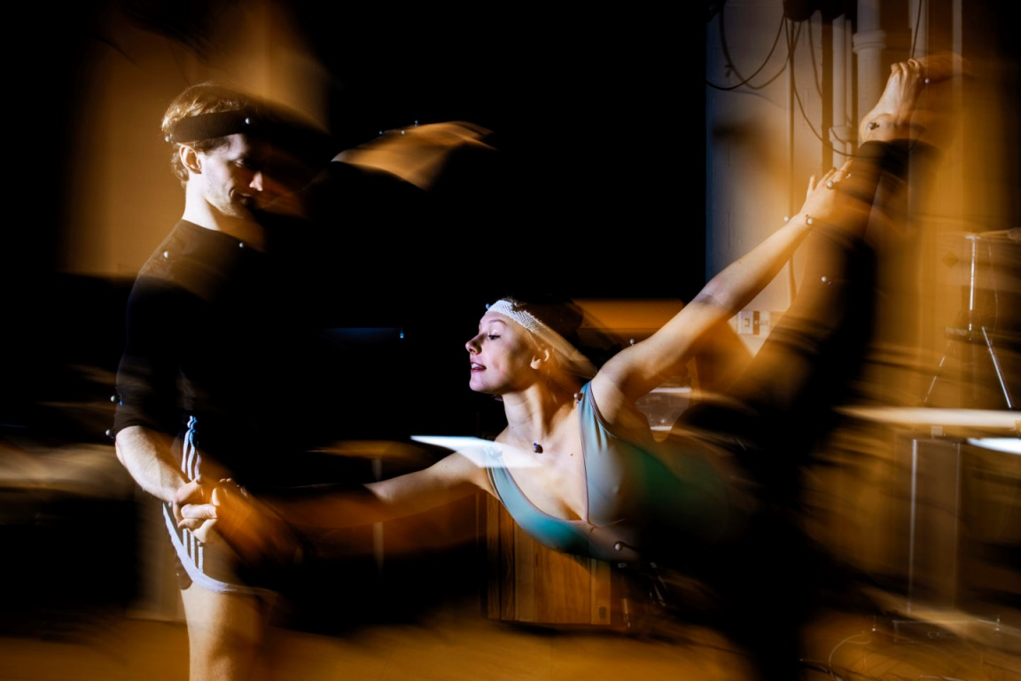

Chalice Lighting - by John Greenleaf Whittier
No longer forward nor behind
I look in hope or fear;
But, grateful, take the good I find,
The best of now and here.

Meditation- Take three minutes to settle into this space, to fully arrive. You may also use this
time to reflect about the chalice lighting words above.

Check-In
As you feel comfortable, take 2-3 minutes to share whatever you need to share with this group in order to be fully present. This is a time for sharing, but not for discussion.

Business (approx. 10 min)
Use this time for any new business: welcoming new members, scheduling future meetings, revisiting/reciting the covenant, answering questions about wisdom circle processes, etc…

Spiritual Exercise
Share any insight, learning, lesson gained from doing or resisting this month’s spiritual exercise. (Focus on your heart/emotions/spirit/personal experience). Because this is a section for personal sharing, attentive listening and no-crosstalk is recommended.
Choose one of the following spiritual exercises:

- Collage- Find some old magazines or download pictures from the internet, take some time to create a collage of what a balanced week would look for you. After you create the collage, reflect on what areas of your life need a little bit more of your attention.

- Meditation – If you’re not a meditator, take 10 minutes of your day to sit in silence and pay attention to the rhythm of your breathing. If you are a meditator, consider experiencing with a type of meditation you haven’t tried or don’t do often.

How was this experience for you? What insight did you gain?

Discussion of Reading and Words of Wisdom
Take turns reading the words of wisdom. Share about the one(s) that caught your attention. Discuss the reading and the questions below. Crosstalk can enrich your conversation here (avoid judging or wanting to “fix” things, and speak from your own experience, avoiding generalizations, and identifying who you mean when/if you use the word “we”).

Words of Wisdom

“Your hand opens and closes, opens and closes. If it were always a fist or always stretched open, you would be paralyzed. Your deepest presence is in every small contracting and expanding, the two as beautifully balanced and coordinated as birds' wings.” ― Jelaluddin Rumi

“Wisdom tells me I am nothing. Love tells me I am everything. And between the two my life flows.” ― Nisargadatta Maharaj

¨Balance is not stasis. Balance is a process of ongoing negotiation and adjustment.¨
― Rev. Nell Veeder Newton

“Life is a constant build up and release of tension. If we go too far in either direction bad things happen.” ― Chris Matakas

“Balance is only meaningful when we choose Love as the center of gravity!”
― Phil 'Philosofree' Cheney

“This selfishness is not only part of me. It is the most living part.
It is somehow transcending rather than by avoiding that selfishness that I can bring poise and balance into my life.” ― F. Scott Fitzgerald

“Life itself consists of phases in which the organism falls out of step with the march of surrounding things and then recovers unison with it—either through effort or by some happy chance. And, in a growing life, the recovery is never mere return to a prior state, for it is enriched by the state of disparity and resistance through which it has successfully passed. If the gap between organism and environment is too wide, the creature dies. If its activity is not enhanced by the temporary alienation, it merely subsists. Life grows when a temporary falling out is a transition to a more extensive balance of the energies of the organism with those of the conditions under which it lives.” ― John Dewey
Balance
Balancing my time is perhaps the constant struggle I face. And it may be exacerbated by the expectation that balance is a thing or a place that we just find and can keep forever, like a point of arrival. I think the experience of a dancer finding balance can shed some light into our constant struggle to find it, too:

“Balance is achieved through the coordination of three body systems: the vestibular system, motor system, and visual system. The vestibular system is located in the inner ear, the motor system is made up of muscles, tendons, and joints, and the visual system sends signals from the eyes to the brain about the current position of the body.
However, staying balanced isn't a matter of staying rigidly in one spot, balance is found by continually shifting the body to make subtle adjustments. Dancing requires these quick changes in the positioning of the body, especially in the feet, ankles, knees, and hips. Because the eyes are not fixated on a single point, a good balance is necessary to make smooth, complete moves.”

This Treva Bedinghaus was posted on the website ThoughtCo., under the title “Improve your balance”. I know she is describing what happens in dancing. However, if you read closely you can see how it connects and relates to life in general.
When we search for balance, we are implying that there are more than one thing pulling us and calling for our attention. We have choices to make. If we don’t, if we stay rigidly in one spot, we don’t achieve balance. The search for balance requires a response from us to begin with. But another thing that I believe it’s important from Treva’s article and that applies to life in general is the need for subtle adjustments in order to find balance.
So balance is not just finding the right spot or point of equilibrium and staying there, but a constant readjustment, an ongoing number of choices and changes. Balance, then, requires that we tap into our ability to adjust quickly to the needs that arise at the moment; it is the art of constant and aware negotiation and decision-making.

Discussion

Can you think of other metaphors for balance?
What has your life taught you about balance?
What areas of your life need more balance?

Gratitude: Share 1-2 things that have been meaningful to you from this session.

Extinguishing of the Chalice: by Kendyl R Gibbons
There is, finally, only one thing required of us: that is, to take life whole, the sunlight and shadows together; to live the life that is given us with courage and humor and truth.
We have such a little moment out of the vastness of time for all our wondering and loving. Therefore, let there be no half-heartedness; rather, let the soul be ardent in its pain, in its yearning, in its praise.
Then shall peace enfold our days, and glory shall not fade from our lives

