Wisdom Circle – Just Love
February 2019

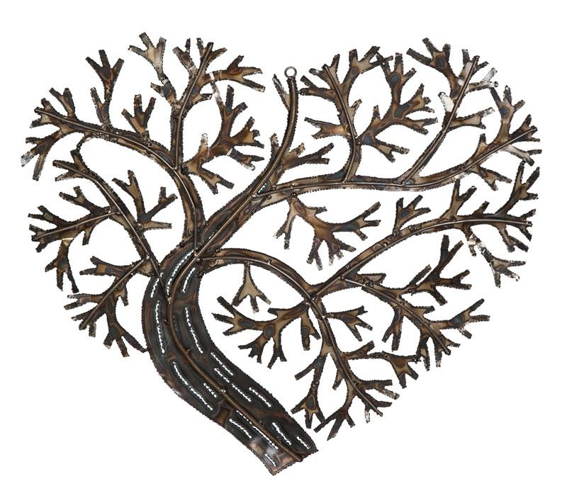

Chalice Lighting - by Maureen Killoran
Love is the aspiration, the spirit that moves and inspires this faith we share.
Rightly understood, love can nurture our spirits and transform the world.
May the flame of this chalice honor and embody the power and the blessing of the love we need, the love we give, the love we are challenged always to remember and to share.

Silence- Take three minutes to settle into this space, to fully arrive. You may also use this
time to reflect about the chalice lighting words above.

Check-In
As you feel comfortable, take 2-3 minutes to share whatever you need to share with this group in order to be fully present. This is a time for sharing, but not for discussion.

Business (approx. 10 min)
Use this time for any new business: welcoming new members, scheduling future meetings, revisiting/reciting the covenant, answering questions about wisdom circle processes, etc…

Spiritual Exercise
Share any insight, learning, lesson gained from doing or resisting this month’s spiritual exercise. (Focus on your heart/emotions/spirit/personal experience). Because this is a section for personal sharing, attentive listening and no-crosstalk is recommended.
Choose one of the following spiritual exercises:

- Journal – Today love was…- During 2-3 days, before you go to bed, write where you saw love that day using the prompt “Today Love was…” (i.e., how you use the word love that day, when you act from a place of love, or when you witness love in action). Based on the information you collect here, what is love for you?

- Reflection – Take some time this month to contemplate these questions: How did you learn about love? Who taught you love? Who loved you into being (the person you are)?

How was this experience for you? What insight did you gain?

Discussion of Reading and Words of Wisdom
Take turns reading the words of wisdom. Share about the one(s) that caught your attention. Discuss the reading and the questions below. Crosstalk can enrich your conversation here (avoid judging or wanting to “fix” things, and speak from your own experience, avoiding generalizations, and identifying who you mean when/if you use the word “we”).

Words of Wisdom

“Darkness cannot drive out darkness: only light can do that. Hate cannot drive out hate: only love can do that.” ― Martin Luther King Jr.

“Being deeply loved by someone gives you strength, while loving someone deeply gives you courage.” ― Lao Tzu

“To love at all is to be vulnerable. Love anything and your heart will be wrung and possibly broken. If you want to make sure of keeping it intact you must give it to no one, not even an animal. Wrap it carefully round with hobbies and little luxuries; avoid all entanglements. Lock it up safe in the casket or coffin of your selfishness. But in that casket, safe, dark, motionless, airless, it will change. It will not be broken; it will become unbreakable, impenetrable, irredeemable. To love is to be vulnerable.” ― C.S. Lewis

“Nobody has ever measured, not even poets, how much the heart can hold.”
― Zelda Fitzgerald

“Love doesn't just sit there, like a stone, it has to be made, like bread; remade all the time, made new.” ― Ursula K. Le Guin

“Love does not begin and end the way we seem to think it does. Love is a battle, love is a war; love is a growing up.” ― James A. Baldwin

“The beginning of love is the will to let those we love be perfectly themselves, the resolution not to twist them to fit our own image. If in loving them we do not love what they are, but only their potential likeness to ourselves, then we do not love them: we only love the reflection of ourselves we find in them” ― Thomas Merton

Just Love

I don’t intend to come up with an all-encompassing definition of love. After all, there are over 70,000 quotes about love in the website Goodreads. Poets, celebrities, spiritual leaders, and almost every human being would understand this word in a similar, though also unique, way. The spiritual exercise this month is an invitation to reflect and articulate our own definition and experience of love, and I also want to invite you to reflect on what Unitarian Universalism, explicitly or implicitly, says about love.

The Reverend Adam Dyer posted this, so timely for our theme of the month, in his blog:

“Faith can actively cultivate love as something primary to human relationships. It can be an antidote to the impersonality and potential violence of purely power-based structures. Love is the only hope to reconcile the history of oppression. Love is the only way to actually be welcoming. And love is what reminds all of us how there is no structure or system that can be truly functional without a healthy, balanced and mutually shared relationship; without such relationships, structure becomes oppression and systems create marginalization. It is in the shadow of these mechanisms where fear and hatred grow.”

And he ends his reflection with this: “Ultimately, Unitarian Universalists must be willing to radically affirm love as something that is a public community mandate and not just a private individual mission. We will never be in right relationship with the full and dynamic range of humanity, whether it be race, class, ability, gender or sexuality…until we openly, unapologetically and consistently put love first.”

I personally find a lot of truth in his words. But I also feel that there is a need for us to understand what we mean by love, to uncover the differences in our understanding of it, to create a collective understanding of love, and to encourage each other to put love first. Sometimes I feel that the excessive use of the word has diluted its meaning. That is why I insist it is necessary that we pause and reflect about what love has been for us and what we mean when we collectively claim that we are on the side of love. What does the side of love look like and who is (not) there?

What do the liturgy (elements of our Sunday service like our aspiration and hymns), UU social justice organizations (Side with Love, Love Resists), and the public discourse we use, have to say about what love is from a Unitarian Universalist perspective? And more specifically, what do they say about this community we claim as our own?

You can read Adam’s complete reflection here: https://spirituwellness.org/2019/01/31/where-is-the-love/

Discussion

What is love?
Are there different types of love?
What lesson(s) have you learned from love?
What do UUs say love is?

Gratitude: Share 1-2 things that have been meaningful to you from this session.

Extinguishing of the Chalice: by David Richo

What makes us human beings so uniquely wonderful in this puzzling universe is that we never give up on love.
Against all odds, with no guarantee of being loved in return, out of the hate and hurt so often handed us, in the face of the sad suffering history has let us see, we go on loving.
What deep respect we deserve for this capacity of ours to make love out of anything and to let it last.

