Wisdom Circle – New Life
April 2019

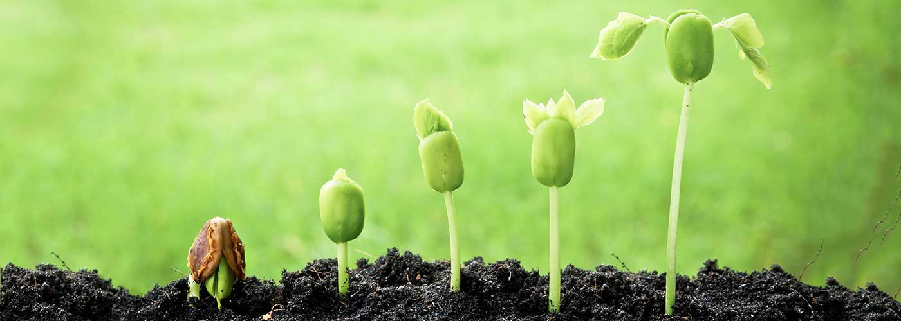

Chalice Lighting - by Jeanny Lloyd
At last, we are here. After a long winter, we can say enthusiastically and without second thought, alleluia! Alleluia, spring is here in all her glory. New life begins, the earth and its creatures are resurrected from their dens of hibernation and dark slumber. Spring is here, long live spring, long live the rebirthing of life into new and creative forms. Long live majestic love that calls us out of our shells, out of our tombs, into new ways of being and sacrifice for others. Let the husks of our shells crack wide open in celebration of our place in humanity, our place in nature, our place in the universe. Awake, awake, rejoice, live life, live life fully, live life together, live life now.

Meditation- Take three minutes to settle into this space, to fully arrive. You may also use this
time to reflect on the chalice lighting words above.

Check-In
As you feel comfortable, take 2-3 minutes to share whatever you need to share with this group in order to be fully present. This is a time for sharing, but not for discussion.

Business (approx. 10 min)
Use this time for any new business: welcoming new members, scheduling future meetings, revisiting/reciting the covenant, answering questions about wisdom circle processes, etc…

Spiritual Exercise
Share any insight, learning, lesson gained from doing or resisting this month’s spiritual exercise. (Focus on your heart/emotions/spirit/personal experience). Because this is a section for personal sharing, attentive listening and no-crosstalk is recommended.
Choose one of the following spiritual exercises:

- Beauty Walk- The rains from our winter months have brought so much beauty to us. The super bloom is at its peak. You need not go to the desert to watch it. Take a walk around your neighborhood and notice what colors or what new sights are beautifying it. If you can, bring a camera with you and take pictures of the things you see that capture your attention. What new beauty can you notice?

- Contemplation – There’s so much life blooming all around us. Spend some time contemplating new life growing in our natural world. Look at a plant or tree with new branches, or a flower bud in silence for a few minutes, and look at it over the course of a few days if possible. Let it speak to you. Listen without judgement.

- Give new life to an old object – Find an old object that you can repurpose and give it new life. It can be anything: a box, a chair, a bucket, etc. Maybe it’s something you were planning to throw away or donate. Spend some time with it, can you create something with it to give it a new use?

How was this experience for you? What insight did you gain?

Discussion of Reading and Words of Wisdom
Take turns reading the words of wisdom. Share about the one(s) that caught your attention. Discuss the reading and the questions below. Crosstalk can enrich your conversation here (avoid judging or wanting to “fix” things, and speak from your own experience, avoiding generalizations, and identifying who you mean when/if you use the word “we”).

Words of Wisdom

“Every new beginning comes from some other beginning's end.” -Seneca

“As I leave the garden
I take with me a renewed view,
And a quiet soul.” ― Jessica Coupe

“Birthing is never easy or without pain, be it a universe, a child, or a fresh start in life. Contraction precedes expansion. Darkness comes before dawn. Joy follows pain. This is the way of things.” ~John Mark Green

“It’s amazing, really, how in one instant a wall can be torn down or climbed over. Misconceptions can be shattered, illusions dashed, dreams irrevocably ruined. Given the right frame of mind, within a heartbeat, people can begin the business of starting over.” ~Tamara Thiel

“What you leave behind says as much about you as what you bring along.” ~Jacquelyn Middleton

“Miracles... seem to me to rest not so much upon... healing power coming suddenly near us from afar but upon our perceptions being made finer, so that, for a moment, our eyes can see and our ears can hear what is there around us always.” ― Willa Cather

Spring is like a perhaps hand – e.e. cummings

Spring is like a perhaps hand
(which comes carefully
out of Nowhere)arranging
a window,into which people look(while
people stare
arranging and changing placing
carefully there a strange
thing and a known thing here)and

changing everything carefully

spring is like a perhaps
Hand in a window
(carefully to
and fro moving New and
Old things,while
people stare carefully
moving a perhaps
fraction of flower here placing
an inch of air there)and

without breaking anything.

New Life – Rev. Tania Márquez

It’s not hard to guess the direct relationship between the theme of this month and the first full month of spring. Almost everywhere you look, one can see signs of new life or rebirth in nature. Life is blooming everywhere, our hills and mountains are covered with new blankets of green and yellow and purple, wildflowers are beautifying our streets, parks, and the sides of the roads. Birds and butterflies are everywhere.
Last month, I had the opportunity to spend time with some women from our congregation at Camp Stevens. On a Saturday morning, a few of us went on a birdwatching hike with a staff person. After a few minutes of our hike, I began noticing that we were in areas that had been affected by the fire in the past. There were traces of it everywhere. But the burnt remnants of trees were surrounded by the growth of new life. It was green everywhere and we were lucky enough to even spot a deer on a nearby mountain. What a contrast!
So there’s the new life that comes with rebirth and renewal, with the ever changing cycles of life. And there’s the new life we, humans, can give things when we assign new meaning or new purpose to them. The first one we get to witness emerge around us with the cycles of life, and the second one we create when we assign new meaning or purpose to objects, to our relationships, and to ourselves.
How have you experienced new life in your life (present and past)? What hopes does the idea of a new life hold for you?

Gratitude: Share 1-2 things that have been meaningful to you from this session.

Extinguishing of the Chalice: by Erica Baron
May you never thirst. May your body and your spirit always have what they need. When you are in need of refreshment, or new life, may the waters be available to you. May you never know thirst unto death, in your body or in your soul. May you never thirst.
And may your body and your spirit always thirst enough to stay alive. May you know the dissatisfaction with things as they are that leads to work for justice. May you know the thirst for new knowledge that leads to the quest for truth. May you know the desire for deeper connection that creates new and stronger relationships. May you know the spiritual thirst that keeps the soul searching, and gives the sweetness of new discovery to faithful followers of spiritual paths of all kinds.
May you never thirst too deeply, but may your thirst never be entirely quenched.

