Wisdom Circle – Letting Go
October 2021

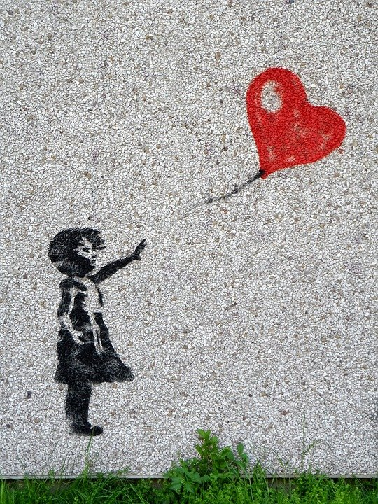
Image by Zorro4 from Pixabay

Chalice Lighting by Kari Kopnick

The things to do have been done, well, for the most part.
The people we need are in place, almost.
We are ready, or as ready as we will be.
Bless this most perfectly imperfect beginning.
May we find the right people to do the right things as we go.
May we discover that what we needed was right here all along.
And may we remember to stop and marvel at the magic of each moment as it floats by.

Silence- Take three minutes to settle into this space, to fully arrive.
You may also use this time to reflect about the chalice lighting words above.

Check-In
As you feel comfortable, take 2-3 minutes to share whatever you need to share with this group in order to be fully present. This is a time for sharing, but not for discussion.

Business
Use this time for any new business: welcoming new members, scheduling future meetings, revisiting/reciting the covenant, answering questions about wisdom circle processes, etc.

Spiritual Exercise
Share any insight, learning, lesson gained from doing or resisting this month’s spiritual exercise. (Focus on your heart/emotions/spirit/personal experience). Because this is a section for personal sharing, attentive listening and no-crosstalk is recommended.

Choose one of the following spiritual exercises. Remember to only try that which calls to you and you feel comfortable doing.

- Song meditation - Find a quiet space and a time that will allow you to focus on this song without interruption or without the need to rush to do the next thing. Take a couple of deep breaths, close your eyes and listen to this song. Pay attention to your thoughts, feelings, and physical reactions. How are you responding to this invitation?
https://www.youtube.com/watch?v=X-_7XfaS7Mc
- Practice Letting Go – find something that is usually difficult for you to let go of, start small, very small and practice what it is. The book you lent to someone, the expectations you have of people around you. You know yourself better, find something that will allow you to practice this without causing you too much stress. The more you practice with the little things, the better you will get to let go of the bigger ones, too.
- Pay attention – Examples of letting go are everywhere. Pay attention, take notes of the things you notice are being let go. Do this over the course of a few days at least, but see what insight you can draw from your observations.

How was this experience for you? What insight did you gain?

Discussion of Reading and Words of Wisdom
Discuss the reading and the questions below. Crosstalk can enrich your conversation here (avoid judging or wanting to “fix” things, and speak from your own experience, avoiding generalizations, and identifying who you mean when/if you use the word “we”).

Words of Wisdom

“Some people think holding on makes us strong; but sometimes it is letting go.”
~Hermann Hesse

“When I let go of what I am, I become what I might be. When I let go of what I have, I receive what I need.” -Tao Te Ching

“People have a hard time letting go of their suffering. Out of a fear of the unknown, they prefer suffering that is familiar.” ~Thich Nhat Hanh

“We must be willing to let go of the life we’ve planned, so as to have the life that is waiting for us.” -Joseph Campbell

“We can’t be afraid of change. You may feel very secure in the pond that you are in, but if you never venture out of it, you will never know that there is such a thing as an ocean, a sea. Holding onto something that is good for you now, may be the very reason why you don’t have something better.” - C. JoyBell C.

“Let go of certainty. The opposite isn’t uncertainty. It’s openness, curiosity and a willingness to embrace paradox, rather than choose up sides. The ultimate challenge is to accept ourselves exactly as we are, but never stop trying to learn and grow.” - Tony Schwartz

Reading (reading selected and questions written by Rev. Jennifer Channin)

Read and reflect on this excerpt called “Letting Go,” from Wherever You Go There You Are by Jon Kabat-Zinn

The phrase “letting go” has to be high in the running for New Age cliché of the century. It is overused, abused daily. Yet it is such a powerful inward maneuver that it merits looking into, cliché or no. There is something vitally important to be learned from the practice of letting go.

Letting go means just what it says. It’s an invitation to cease clinging to anything—whether it be an idea, a thing, an event, a particular time, or view, or desire. It is a conscious decision to release with full acceptance into the stream of present moments as they are unfolding. To let go means to give up coercing, resisting, or struggling, in exchange for something more powerful and wholesome which comes out of allowing things to be as they are without getting caught up in your attraction to or rejection of them, in the intrinsic stickiness of wanting, of liking and disliking. It’s akin to letting your palm open to unhand something you have been holding on to.

But it’s not only the stickiness of our desires concerning outer events which catches us. Nor is it only a holding on with our hands. We hold on with our minds. We catch ourselves, get stuck ourselves, by holding, often desperately, to narrow views, to self-serving hopes and wishes. Letting go really refers to choosing to become transparent to the strong pull of our own likes and dislikes, and of the unawareness that draws us to cling to them. To be transparent requires that we allow fears and insecurities to play themselves out in the field of full awareness.

Letting go is only possible if we can bring awareness and acceptance to the nitty-gritty of just how stuck we can get, if we allow ourselves to recognize the lenses we slip so unconsciously between observer and observed that then filter and color, bend and shape our view. We can open in those sticky moments, especially if we are able to capture them in awareness and recognize it when we get caught up in either pursuing and clinging or condemning and rejecting in seeking our own gain.

Stillness, insight, and wisdom arise only when we can settle into being complete in this moment, without having to seek or hold on to or reject anything. This is a testable proposition. Try it out just for fun. See for yourself whether letting go when a part of you really wants to hold on doesn’t bring a deeper satisfaction than clinging.

Questions for Reflection:

- What is something you have had to let go of in your life? How did it feel to let it go?
- What is something “sticky” in your life right now—a desire, an idea, a thing, a perspective that it is hard to let go of?
- Have you ever felt completely “in this moment”? What brought about that feeling?

Gratitude: Share 1-2 things that have been meaningful to you from this session.

Extinguishing of the Chalice: by Mary Oliver, from “In Backwater Woods”

To live in this world

you must be able
to do three things:
to love what is mortal;
to hold it

against your bones knowing
your own life depends on it;
and, when the time comes to let it go,
to let it go.

